A Comparative Study of Extractive and Abstractive Text Summarization Techniques
Natural Language Processing Mini Project Report
By
Rishik Reddy Bandi – 220968300
Mandar Sanjay Chaudhari - 220968222

1. Introduction

• Brief overview of NLP:
Natural Language Processing (NLP) is a subfield of artificial intelligence focused on enabling computers to process, understand, and generate human language. It bridges the gap between human communication and computer interpretation, powering applications like machine translation, sentiment analysis, chatbots, and text summarization.

• Problem statement:
The sheer volume of text generated daily (news articles, emails, research papers, social media) makes it challenging for humans to consume and extract key information efficiently. Automatic Text Summarization aims to address this by creating concise and informative summaries of longer documents, saving time and improving information access. The primary challenge lies in generating summaries that are not only shorter but also relevant, coherent, fluent, and factually accurate.

• Motivation for the project:
Text summarization techniques fall broadly into two categories: extractive and abstractive. Extractive methods select important sentences directly from the source, ensuring factual grounding but often lacking coherence. Abstractive methods generate new sentences, potentially achieving better fluency and conciseness like human summaries, but risk generating inaccuracies and require more complex models. Understanding the practical performance differences, computational costs, and qualitative nuances between modern implementations of these two approaches (specifically graph-based extractive vs. Transformer-based abstractive) was the primary motivation for this project.
• Objectives and goals:
The main objectives of this project were:
1. To implement a representative extractive summarization technique (TextRank).
2. To implement and fine-tune representative abstractive summarization models (T5 variants).
3. To evaluate and compare these methods quantitatively using standard metrics (ROUGE scores, generation time).
4. To perform qualitative analysis to assess summary relevance, fluency, coherence, and factuality.
5. To compare against a state-of-the-art pre-trained abstractive model (BART) as a benchmark.
6. To explore the generation of different summary formats (e.g., multi-sentence, one-line).
7. To develop a simple web application demonstrating the implemented summarization techniques.

2. Literature Review

• Overview of existing methods and techniques:

Text summarization methods have evolved significantly.
o Extractive techniques were dominant earlier. Simple approaches include selecting the leading sentences (Lead-3 baseline). More sophisticated methods involve scoring sentences based on features like term frequency (TF-IDF), position, or presence of keywords. Graph-based methods like TextRank (Mihalcea & Tarau, 2004) and LexRank (Erkan & Radev, 2004) model sentence relationships to identify central sentences.
o Abstractive techniques traditionally involved complex rule-based systems or statistical methods with limited success. The advent of deep learning, particularly sequence-to-sequence (seq2seq) models using Recurrent Neural Networks (RNNs) with attention mechanisms, marked a significant advance. More recently, Transformer-based models (Vaswani et al., 2017) like T5, BART, and PEGASUS have become state-of-the-art, leveraging large-scale pre-training and fine-tuning to generate high-quality, fluent, and coherent abstractive summaries.

• Key papers/Models that inspired the project:

o PageRank Algorithm (Page et al., 1999): While for web ranking, its core idea inspired the graph-based ranking in TextRank.
o TextRank (Mihalcea & Tarau, 2004): Provided the specific extractive algorithm implemented.
o Attention Is All You Need (Vaswani et al., 2017): Introduced the Transformer architecture, the foundation for T5 and BART.
o Exploring the Limits of Transfer Learning with a Unified Text-to-Text Transformer (Raffel et al., 2020): Introduced the T5 model and its text-to-text framework.
o BART: Denoising Sequence-to-Sequence Pre-training for Natural Language Generation, Translation, and Comprehension (Lewis et al., 2020): Introduced the BART model, highly effective for generative tasks like summarization.
o Lin (2004): Introduced the ROUGE metric for automatic summarization evaluation.

• Summary of relevant research:

Current research indicates that large pre-trained Transformer models (BART, T5, PEGASUS) fine-tuned on large summarization datasets generally achieve the highest performance on metrics like ROUGE for abstractive summarization benchmarks like CNN/Daily Mail. However, they come with significant computational costs for training and inference. Extractive methods remain relevant due to their speed, simplicity, and guaranteed factual grounding (as they only use source sentences), serving as important baselines and practical solutions in resource-constrained environments. Evaluating summaries remains challenging, with ROUGE providing a measure of overlap but failing to capture aspects like factuality, coherence, and relevance comprehensively, necessitating qualitative human evaluation.

3. Methodology

• Description of the dataset used:

The project utilized the CNN/Daily Mail dataset, accessed via the Hugging Face datasets library (version 3.0.0). This is a large-scale benchmark dataset widely used for abstractive summarization.
o Source: Consists of news articles (from CNN and Daily Mail websites) paired with several human-written highlights (abstractive summaries).
o Size: Contains approximately 287,000 training pairs, 13,000 validation pairs, and 11,500 test pairs.
o Features: Each instance includes the full article text and the corresponding highlights (reference summary).
o Nature: Articles cover various news topics. The highlights are typically multi-sentence but concise, capturing the main points abstractively.

• Data preprocessing steps:

o For TextRank: Primarily involved sentence tokenization, handled internally by the sumy library which uses NLTK's punkt and punkt_tab tokenizers. No explicit stemming, lemmatization, or stopword removal was performed outside the library's implementation.
o For T5:
1. Prefixing: Added the task-specific prefix "summarize: " to the beginning of each input article, as required by the T5 model's text-to-text framework during fine-tuning.
2. Tokenization: Used the specific T5Tokenizer corresponding to the T5 model variant (t5-small, t5-base, t5-large). This involves converting text into subword tokens (using SentencePiece).
3. Sequence Length Handling: Truncated input articles (article) to a maximum length (e.g., 512 tokens) and target summaries (highlights) to a maximum length (e.g., 128 or 150 tokens). Padded shorter sequences to the maximum length for batch processing.
4. Target Formatting: Tokenized the target summaries separately using the tokenizer in target mode.

• Model architecture and algorithms employed:

o TextRank: Implemented using the sumy library. It constructs a graph where sentences are nodes and edge weights are determined by sentence similarity (likely TF-IDF based in sumy's default). The PageRank algorithm identifies the most central (important) sentences, which are then extracted to form the summary.
o T5 (Text-To-Text Transfer Transformer): An encoder-decoder Transformer model. Both encoder and decoder use stacked Transformer layers with self-attention. The encoder processes the input article, and the decoder autoregressively generates the summary tokens, attending to the encoder's output (via cross-attention) and previously generated summary tokens (via self-attention). Pre-trained on a massive text corpus using a text-to-text objective and fine-tuned on CNN/DM for summarization. Variants t5-small, t5-base, and t5-large were used/tested, differing in the number of layers, hidden size, and attention heads.
o BART (Bidirectional Auto-Regressive Transformer): Another encoder-decoder Transformer model. It uses a standard Transformer encoder but modifies the pre-training objective to involve denoising corrupted input text (e.g., text infilling), making it particularly effective for generation tasks. The facebook/bart-large-cnn checkpoint, pre-trained and fine-tuned on CNN/DM, was used via the Hugging Face pipeline.

• Training process:

o TextRank: Requires no training.
o T5: Fine-tuning was performed using the Hugging Face Trainer and Seq2SeqTrainer classes on Kaggle infrastructure (GPU/TPU).
- Framework: PyTorch.
- Optimizer: AdamW (standard for Transformers).
- Learning Rate: 1e-5, 2e-5, 3e-5.
- Batch Size: Varied (e.g., 4, 8) depending on model size and hardware (GPU/TPU memory). Gradient accumulation was sometimes used.
- Epochs: 1-3.
Data Subsets: Experiments were conducted using both full datasets and subsets (e.g., 1k training samples for T5-large experiment) due to resource/time constraints.
Checkpointing: Saved best model based on validation loss or ROUGE score.
o BART: Used the pre-trained and pre-fine-tuned facebook/bart-large-cnn model directly; no training performed in this project for BART.

• Evaluation metrics used:

o ROUGE (Recall-Oriented Understudy for Gisting Evaluation):
- ROUGE-1: Overlap of unigrams (single words).
- ROUGE-2: Overlap of bigrams (pairs of words).
- ROUGE-L: Longest common subsequence (sentence structure similarity).
Reported F1-scores for each. Calculated using the evaluate library.
o Average Generation Time: Measured inference time per sample (in seconds).
o Qualitative Criteria: Relevance, Coherence, Fluency, Factuality, Conciseness (assessed manually).

4. Implementation

• Description of the tools and libraries used:

o Language: Python 3.x
o Core NLP/ML: transformers (for T5, BART models, tokenizers, pipelines, Trainer), torch (deep learning framework), datasets (loading CNN/DM), evaluate (for ROUGE).
o Extractive Summarization: sumy, nltk (for tokenizers used by sumy).
o Data Handling/Analysis: pandas (structuring results), json (saving results).
o Visualization: matplotlib, seaborn (plotting quantitative results).
o Web Application: streamlit (building the interactive demo).
o Environment: Kaggle Notebooks (for training/analysis leveraging GPU/TPU), Local environment (for Streamlit app).

• Code snippets or key implementation details:

o T5 Fine-tuning Setup: Utilized Seq2SeqTrainer with Seq2SeqTrainingArguments to manage the training loop, evaluation, and saving of T5 models. Data processing involved mapping a preprocess_function_t5 across the dataset.
o TextRank Usage: Instantiated PlaintextParser and TextRankSummarizer from sumy to generate summaries.
o BART Usage: Employed pipeline("summarization", model="facebook/bart-large-cnn") for easy inference with the pre-trained model.
o ROUGE Calculation: Loaded the metric via evaluate.load('rouge') and used its compute() method.
o Streamlit App: Structured using st.title, st.markdown, st.columns, st.selectbox, st.slider, st.text_area, st.code, st.button, st.spinner, and @st.cache_resource / @st.cache_data for efficiency.

• Challenges faced during development:

1. Computational Resources: Training T5-base and especially T5-large required significant GPU/TPU time and memory, necessitating careful management on Kaggle.
2. Training Data Size: Demonstrating the performance impact of insufficient training data when attempting to fine-tune T5-large on only 1k samples.
3. Environment/Dependencies: Ensuring correct installation of PyTorch/XLA for TPU runs; resolving NLTK resource errors (punkt_tab) needed by sumy.
4. Streamlit Nuances: Correctly ordering st.set_page_config; handling widget updates and state management (st.session_state); finding suitable methods for text display with copy functionality (st.code vs. st.text_area).
5. Evaluation Limits: Recognizing the limitations of ROUGE and the critical need for time-consuming qualitative analysis to get a true picture of model performance (especially factuality and relevance).
6. Model Failures: Encountering inference errors even with the robust BART pipeline on certain inputs.

5. Results and Analysis

• Visualizations:

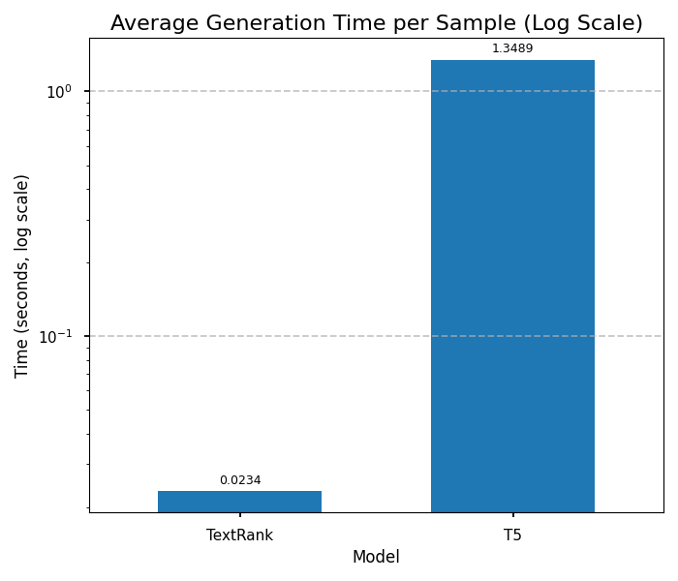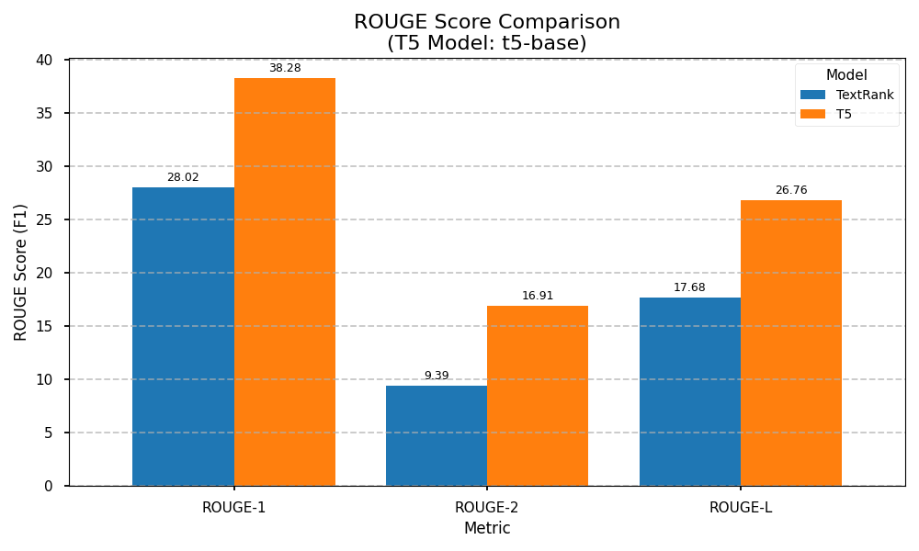

• Performance analysis and interpretation:

The quantitative results (Table presented in Section III.1) clearly show a performance hierarchy based on ROUGE scores: BART-large-cnn (estimated highest) > T5-base (well-trained) > T5-large (1k samples) > T5-small (trained) > TextRank. This generally aligns with expectations regarding model size and specific fine-tuning, with the crucial exception of the under-trained T5-large. TextRank provides the fastest inference by orders of magnitude, establishing a clear speed-quality trade-off against the abstractive models.
Qualitative analysis (detailed in Section III.2) provided critical context. BART produced the highest quality summaries overall – fluent, relevant, and accurate. T5-base was also strong qualitatively. T5-small was adequate but less consistent. T5-large (1k) was unreliable, often failing to capture the main point or making factual errors, despite its fluency and reasonable ROUGE scores relative to TextRank. This highlighted that ROUGE can be misleading for poorly trained models. TextRank's output lacked coherence but was factually grounded and sometimes captured key points missed by the under-trained T5 model. BART encountered inference errors on a few samples, indicating potential robustness issues in the pipeline for certain edge cases.

• Comparison with baseline models:

All abstractive models significantly outperformed the TextRank baseline on ROUGE scores. However, only the well-trained T5-base and the pre-trained BART model consistently demonstrated superior qualitative performance. The under-trained T5-large, while scoring better than TextRank on ROUGE, was arguably less useful due to its unreliability. This emphasizes that simply using a larger/abstractive model doesn't guarantee better results than a simple baseline if not trained properly.

6. Conclusion

• Summary of key findings:
This project successfully compared extractive (TextRank) and various abstractive (T5 variants, BART) summarization techniques. Key findings include:
1. Well-trained abstractive models (T5-base, BART-large-cnn) significantly outperform TextRank in summary quality (fluency, coherence, relevance) as measured by both ROUGE scores and qualitative analysis but incur a substantial cost in inference time.
2. Sufficient fine-tuning data is critical for large abstractive models; under-training (e.g., T5-large on 1k samples) leads to unreliable and potentially inaccurate summaries, despite higher fluency than extractive methods.
3. ROUGE scores are necessary but insufficient for comprehensive evaluation; qualitative analysis is crucial to identify issues like poor relevance or factual errors that ROUGE may not capture.
4. Pre-trained models fine-tuned on the specific task dataset (like facebook/bart-large-cnn) offer a highly effective shortcut to state-of-the-art performance compared to fine-tuning large models from scratch without adequate resources/data.

• Potential improvements and future work:

1. Full Fine-tuning: Fine-tune T5-large (or even larger models like T5-3b if resources allow) on the complete CNN/Daily Mail dataset for potentially improved performance.
2. Enhanced Extractive Methods: Implement TextRank using sentence embeddings (e.g., from Sentence-BERT) for similarity calculation, which might improve its relevance.
3. Advanced Evaluation: Incorporate metrics beyond ROUGE, such as BERTScore (semantic similarity) or fact-checking methods/metrics.
4. Cross-Dataset Evaluation: Test the fine-tuned models on different summarization datasets (e.g., XSum, Reddit TIFU) to assess generalization.
5. Error Analysis: Perform a more systematic analysis of the types of errors each model makes (e.g., entity errors, hallucinated facts, missed key points).
6. Format Generation: Further refine techniques for reliably generating specific formats like accurate bullet points from abstractive models.

7. References

• Erkan, G., & Radev, D. R. (2004). LexRank: Graph-based lexical centrality as salience in text summarization. Journal of Artificial Intelligence Research, 22, 457-479.
• Lewis, M., Liu, Y., Goyal, N., Ghazvininejad, M., Mohamed, A., Levy, O., Stoyanov, V., & Zettlemoyer, L. (2020). BART: Denoising Sequence-to-Sequence Pre-training for Natural Language Generation, Translation, and Comprehension. arXiv preprint arXiv:1910.13461.
• Lin, C. Y. (2004). ROUGE: A Package for Automatic Evaluation of Summaries. In Text Summarization Branches Out, pp. 74-81. Association for Computational Linguistics.
• Mihalcea, R., & Tarau, P. (2004). TextRank: Bringing Order into Texts. In Proceedings of the 2004 Conference on Empirical Methods in Natural Language Processing (EMNLP), pp. 404-411.
• Page, L., Brin, S., Motwani, R., & Winograd, T. (1999). The PageRank citation ranking: Bringing order to the web. Stanford InfoLab.
• Raffel, C., Shazeer, N., Roberts, A., Lee, K., Narang, S., Matena, M., Zhou, Y., Li, W., & Liu, P. J. (2020). Exploring the Limits of Transfer Learning with a Unified Text-to-Text Transformer. Journal of Machine Learning Research, 21(140), 1-67.
• Vaswani, A., Shazeer, N., Parmar, N., Uszkoreit, J., Jones, L., Gomez, A. N., Kaiser, Ł., & Polosukhin, I. (2017). Attention is All You Need. In Advances in Neural Information Processing Systems 30 (NIPS 2017), pp. 5998-6008.
• Hugging Face Datasets Library: https://huggingface.co/datasets
• Hugging Face Transformers Library: https://huggingface.co/transformers
• Sumy Summarization Library: https://github.com/miso-belica/sumy
• Streamlit Documentation: https://docs.streamlit.io/
• CNN/Daily Mail Dataset Card: https://huggingface.co/datasets/cnn_dailymail

8. Appendix

o Codes included in lms submission.
o Screenshots of the Streamlit application.



